me,Eá iy .ia je,a

wm wjg we;s .iaje,a j,g wms wdorh lruq'
wm wjg we;s YdL j¾. m%Odk jYfhka fldgia 4 ls'
1' .ia 2'je,a 3' m÷re 4' me,Eá
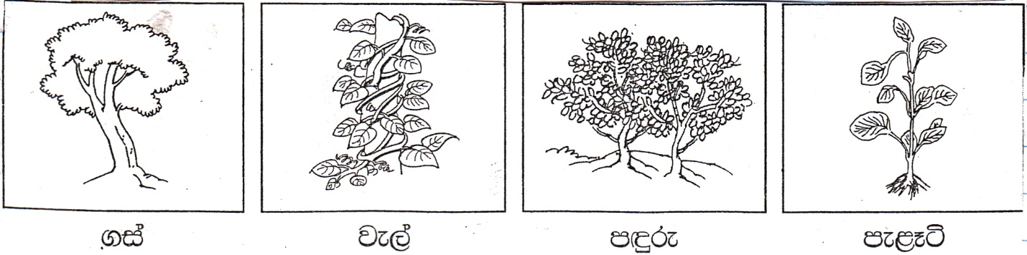

.iaj, úúO ,ËK
.iaj, l| Yla;su;a
.ia Wiaj jefjkjd
we;eï .iaj, w;= fnfoawe;eï .iaj, w;= fkdfnfoa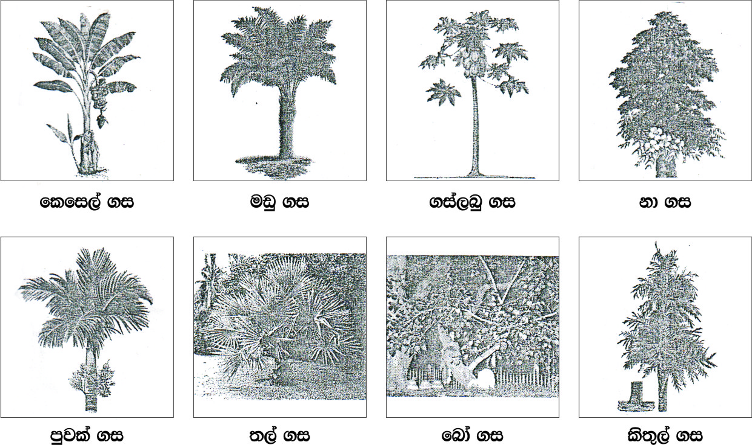

úúO .ia j¾.
l¿jr" fmd,a" wU" nqre;" mefmd,a" fodvï
;d, j¾.hg wh;a .ia
fmd,a" ;,a" ls;=,a" mqjla ^w;= fkdfnfoa' uqÿka uq,la fkdue;&
jákd ±j j¾. ,nd .kakd .ia
l¿jr" y,añ,a," f;alal" l¿ueÈßh" ufyda.kS" fldia
je,a j, úúO ,ËK
je,a j,g ;ksfhka by<g .uka l< fkdyelsh' kuq;a wdOdrlh u; t;S by<g k.S'
úúO je,a j¾.
jÜglald " lrú," jegfld¿" msms[a[d" lelsß" oU," fmfk<" bruqiq" w`.=K" yd;djdßh" .ïñßia" nq,;a" je,a fodvï
m÷re j, úfYaI ,ËK
b;d Wig fkdjefvk" w;= úys§ hk YdL j,g wms m÷re lshuq'
m÷re j,g WodyrK
rïfma" fmar" b¿la" udk" iejekaord" f.dhï" WK" ly" b`.=re
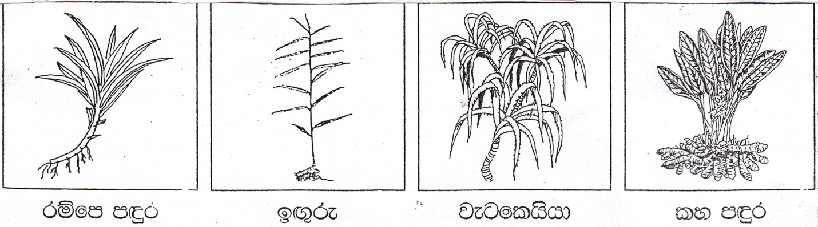

me<Eá
b;d Wig fkdjefvk" w;= úys§ fkdhk YdLj,g wms me<Eá lshuq'

me<Eá j,g WodyrK
fudKrl=vqïìh" l=mamfïkshd" fmd,am,d" ñßia" yq<x;,d" l+v¨" l,d÷re" uÿre;,d
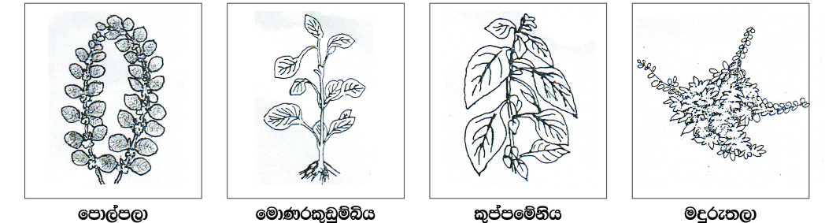

.iaje,a f,dl= ù u,a msmS M,yg .kS'
.iaje,aj, u,a j,ska wjg iqkaorfõ' iuyr u,a yg .kafka hï lsis ld,hlg muKs'

u,l fldgia
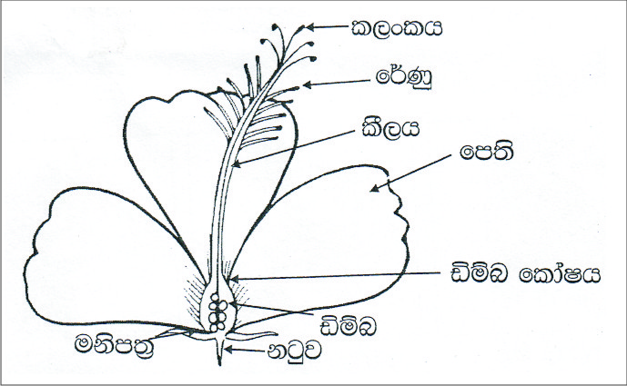
ld,hlg msfmk u,a j¾.
trnÿ u,a
fjila u,a
weye< u,a
ìkr u,a
uehs u,a
wU u,a
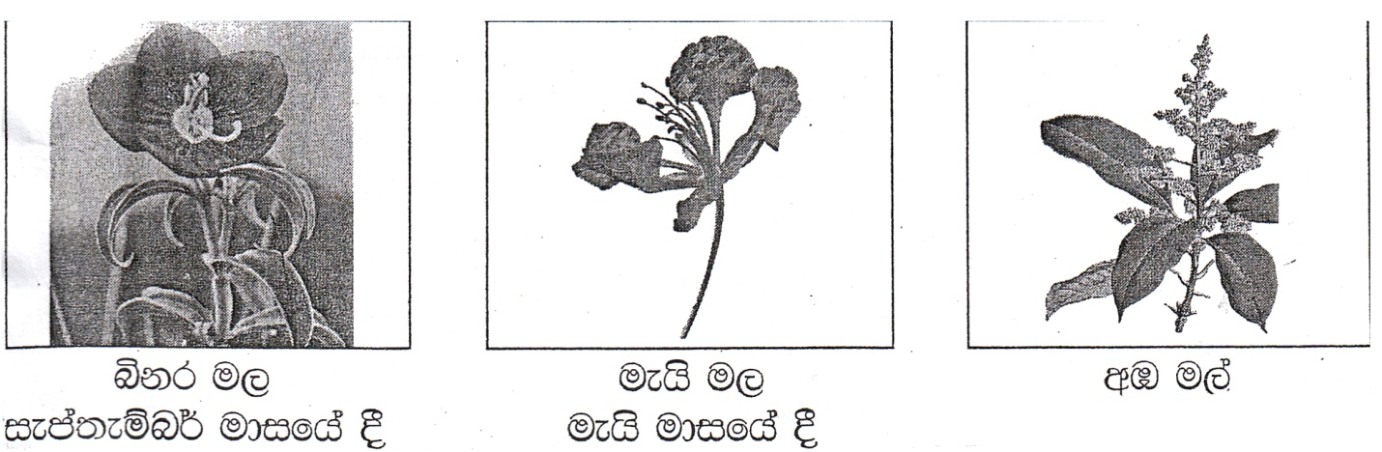

wjqreoao mqrdu msfmk u,a j¾.
fmd,a u,
fnda.kaú,d u,
flfi,a u,
jä. u,
boao u,
wr,shd u,
uqiekavdia u,
msÉp u,
l+v¨ u,
fâ,shd u,
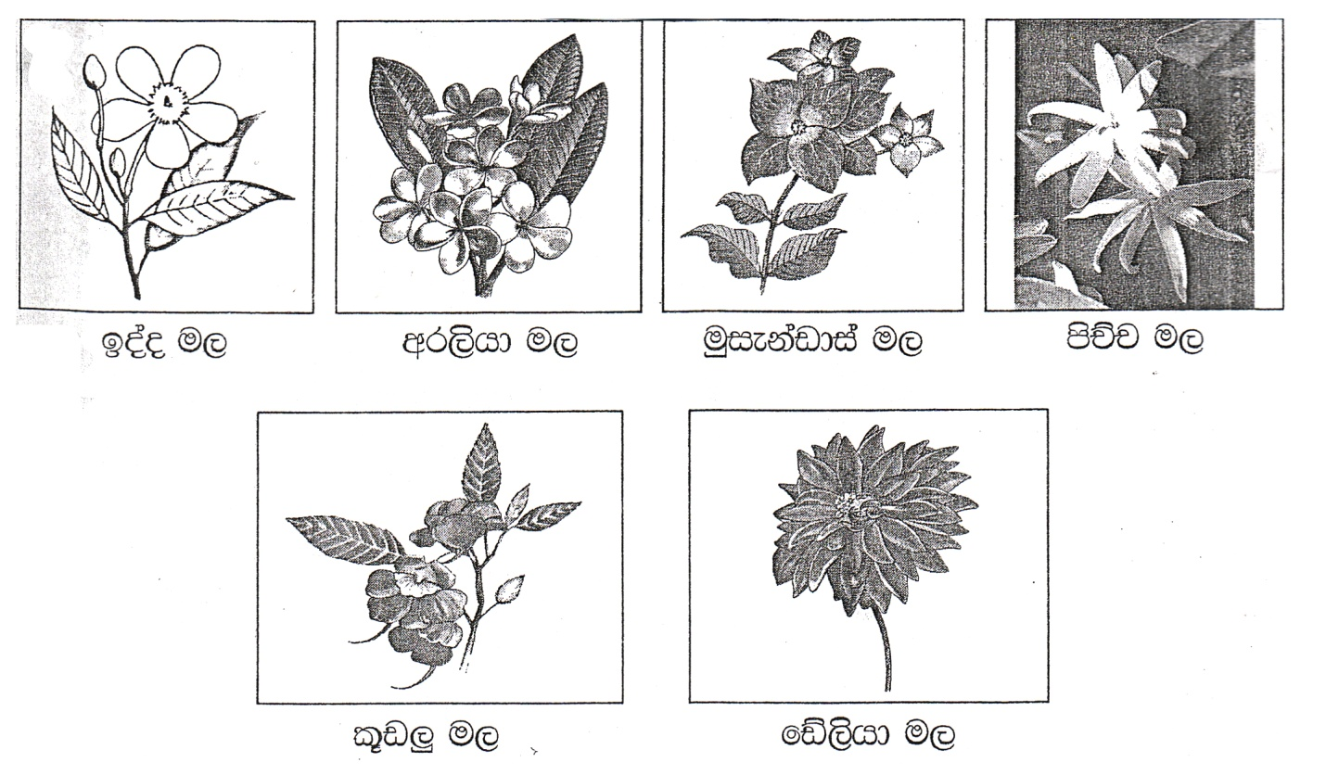

ieliqu(
ví'wd¾' .S;dks m%kdkaÿ
4 fY%aKsh
031 2245426

